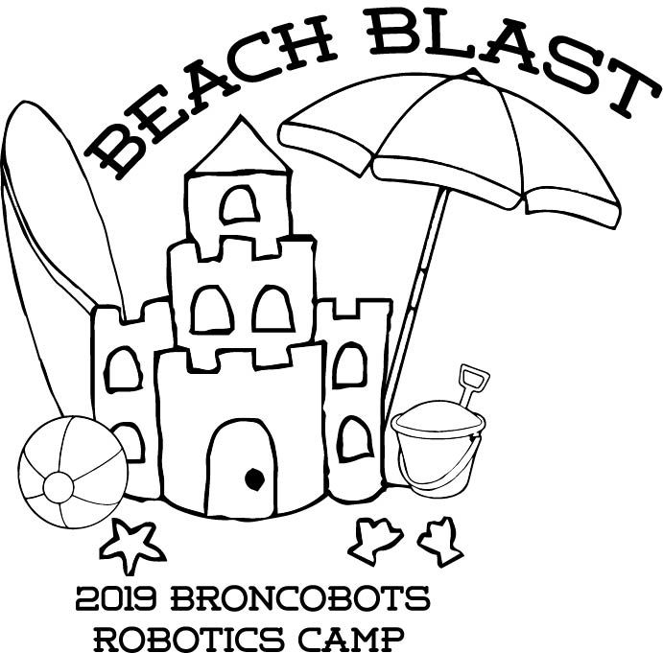

Version 1.0

1 Objective

Beach Blast is a game that focuses on driving skill and engineering design. Teams will construct a remote controlled robot capable of moving game pieces to score into sandcastles, beach pails, and through a net.

2 The Game

2.1 The Field

2.1.1 The Beach
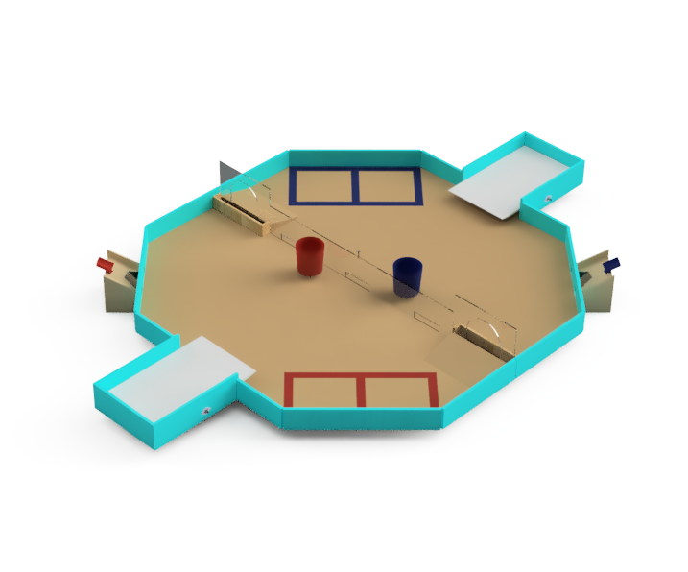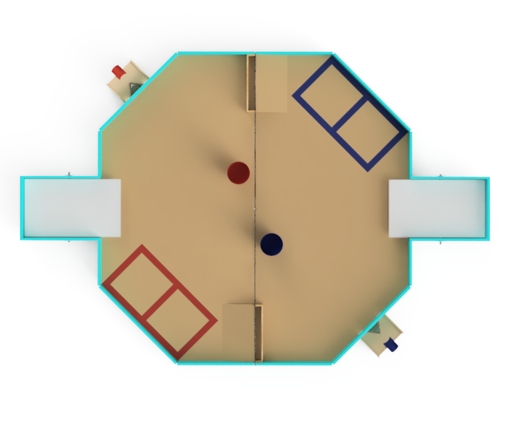

The Beach is an octagon with 48 inch and 34 inch sides containing all of the scoring zones. The scoring zones are as follows:

2.1.2 Sandcastle

The Sandcastle is a 10 inch wide opening in the Volleyball Net. The back of the Sandcastle is a 17 inch long by 2 inch wide by 3.5 inch deep box where Beach Balls are scored.

2.1.3 Beach Pail

The Beach Pail is a 9.25 inch diameter, 7 inch tall scoring area on either side of the Volleyball Net where Beach Balls are scored. The Beach Pail is filled with 6 inches of foam so that there is a 1 inch deep area for Beach Balls to be scored in. Each alliance’s Beach Pail is placed on the opposite side of the field of their Starting Zones.

2.1.4 Sand Dunes

The Sand Dunes are two 18 inch wide 14° inclines in front of the Sandcastle.

2.1.5 The Starting Zones

Both alliances have Starting Zones located on opposite sides of the field from the other alliance. There will be a blue side and a red side.

2.1.6 Volleyball Net

The Volleyball Net is a 96 inch long clear Lexan sheet that runs the length of the field. The Net contains three openings on the bottom which are 8 inches wide and 2.5 inches tall. Beach Balls can be moved through the openings to either side of the field.

2.1.7 Surfboard

The Surfboard is an 18 inch wide by 30 inch long plywood plank that pivots near center. Two robots can theoretically fit on the Surfboard. The end of the Surfboard furthest away from the field will tilt down if a robot drives on it.

2.1.8 Water Slide

The Water Slide is an 11.5 inch wide ramp with a two 2 inch openings to the field with a dividing wedge to evenly distribute the inbound Beach Balls. The human player deposits the Beach Balls down the waterslide and onto the field. Beach Balls must contact the PVC pipe before they enter the field.

2.2 The Robot

2.2.1 Robot Dimensions

The Robot must always begin the game with a configuration not exceeding a 14 x 14 x 14 inch cube but is allowed to expand once the game begins. Please be mindful of our limited supply of parts, all teams share the same parts store.

2.2.2 Robot Safety

The robot may not have any parts, abilities, or systems that could be considered dangerous or are aimed at the destruction of other robots or the field. Teams in violation of this rule will not be allowed to compete until the function is rectified.

2.3 Game Rules

2.3.1 General Playing Rules

2.3.1.1 The total time of each match will be two and a half minutes long.

2.3.1.2 The alliances will start the game in their respective Starting Zones, located at the ends of the Beach. The two alliances are red and blue.

2.3.1.3 The alliances will score in their respective color coded scoring zones and on either side of the Volleyball Net.

2.3.1.4. Drivers or Human Players may not reach onto the field, this includes but is not limited to touching the robot, Beach Balls and other field elements.
2.3.1.5 No destruction of field pieces.

2.3.1.6 No robot may de-score any of the opposing alliance’s Beach Balls scored in either the Beach Pail or Sandcastle.

2.3.1.7 No robot may block the opposing alliance from scoring in the Sandcastle or Beach Pail.

2.3.1.8 During the last 30 seconds of the match, the human player for each alliance must step out of the human player box for their alliance. Then, a human player from the opposing alliance, called the Lifeguard, may enter the human player box and begin using the Water Slide if they choose. The Lifeguard and Human player may not interfere with each other or the Water Slide while the other players is in the Human Player Box.

2.3.1.9 In the case of a tie, the team with the highest number of Surfboard points wins. If the tie persists, the team with the highest number of Beach Pail points wins. If the tie still persists, the team with the highest number of Sandcastle points wins. If the tie continues to persist after that, the team with the highest number of Beach Balls on the opposing alliance side of the field wins. If a tie persists after all tie breakers. The match may be replayed.

2.3.2 Game Pieces

2.3.2.1 Beach Balls
Beach Blast is played using Beach Balls. Beach Balls are small 1.68 inch diameter Practice Golf balls. Beach Balls can be scored in the Sandcastle, Beach Pail, and either side of the Volleyball Net of their own Alliance. There will be a total of 67 Beach Balls in play. At the beginning of the match, 13 Beach Balls will be placed in a line on each side of the field. Each human player station will have 20 balls each. A single Beach Ball will sit atop the Volleyball Net in the center of the field.

2.3.2.2 The objective of the game is to score the most points by the end of the two and a half minute match period.

2.3.2.3 If any game piece leaves the field during the game, a judge will work to place the piece back onto the field as close as possible to the point it left the field.

2.3.3 Scoring
Location | Point Values
Beach Balls on Opposing Alliance Side of Field | 1 point per Beach Ball
Sandcastle | 2 points per Beach Ball
Beach Pail | 5 points per Beach Ball

2.3.3.1 End Game Scoring
Robots may climb the Surfboard at any point during the last 30 seconds of the match. For the score to count, the robot(s) must have the board tipped away from the field when the timer hits 0. More points will be awarded for both robots using teamwork to climb at the same time. For the first robot on the Surfboard, the alliance will receive 10 points. For the second robot on the Surfboard, the alliance will receive an additional 25 points for a maximum total Surfboard score of 35 points.

2.3.4 Penalties

Penalties will be assessed solely by the Referees based on their good judgment. All decisions by referees are final and any arguments with referees will be interpreted as unsportsmanlike conduct. All penalties will be added to the opposing alliance’s score.

Beach Ball not touching PVC 2 points per ball
Human Player Box Infraction 8 points
Unsportsmanlike conduct 2 points
Second offense 4 points
Third offense Ejection of offending team
Human Interference 6 points
Driver Zone Infraction 2 points
False Start 2 points
Destruction of Field Elements 6 points

2.3.5 Sportsmanship

Participants are expected to demonstrate good sportsmanship and the FIRST ideal of Gracious Professionalism at all times. The true objective of the Broncobots Robotics Camp is to teach campers as much as possible in a friendly, relaxed atmosphere. Participants should demonstrate gracious professionalism by looking to help other teams with issues, sharing tools and treating everyone involved with respect.

3 Kit of Parts

3.1 Available Parts

All parts used for construction of the robot must come from the VEX kits provided by the Broncobots Robotics Camp.

3.2 Decorative Parts

Anything may be used for decoration, but all decorations must be approved by Broncobots Staff.

4 Awards

4.1 Grand Champions

The Grand Champion Award is presented to the alliance that wins the competition.

4.2 All-Star Award

The All-Star Award is presented to the team that worked towards and achieved excellence in the pursuit of all aspects of the Beach Blast game.

4.3 Sportsmanship Award

The Sportsmanship Award is presented to the team that has demonstrated good sportsmanship and Gracious Professionalism throughout the competition.

4.4 Imagery Award

The Imagery Award is presented to the team that most creatively integrates a theme into their robot, their team name, mascot, decorations, etc. This award is based both on teams’ ideas for their themes and the execution of their designs.

4.5 Spirit Award

This award goes to the team that demonstrates a high level of enthusiasm for their team, their alliance, their opponents, and the Beach Blast game in general.

4.6 Website Award

The Website Award is presented to the team that has, in the opinion of the Beach Blast staff, the best webpage.

4.7 Marketing Award

The Marketing Award is presented to the team with the most visually pleasing and most effective camp flyer. This award is judged by the camp staff on qualities such as content, graphic layout and “eye-catching ability.”

4.8 Safety Award

The Safety Award is presented to the team that most consistently demonstrates throughout the camp safe work practices while encouraging other teams to be safe.

4.9 Judges Award

The Judges Award does not fit into any other category. It is presented to the team that catches the eye of the Judges through some type of unique feature.

5 Rule Modification

5.1 Rule Modification

These rules may be modified by the Beach Blast staff at any time to correct errors, rectify loopholes and generally provide a better experience for the participants. Every effort will be made to expedite the modification process and the staff will give teams a new copy of the rules as soon as possible following changes. Once you have read all of the rules, give Kameron, Emma, and Jonah a high five.

